
For more information:
Sarah Wynn Benton
BRAVE Public Relations
404.233.3993
sbenton@emailbrave.com

FOR IMMEDIATE RELEASE

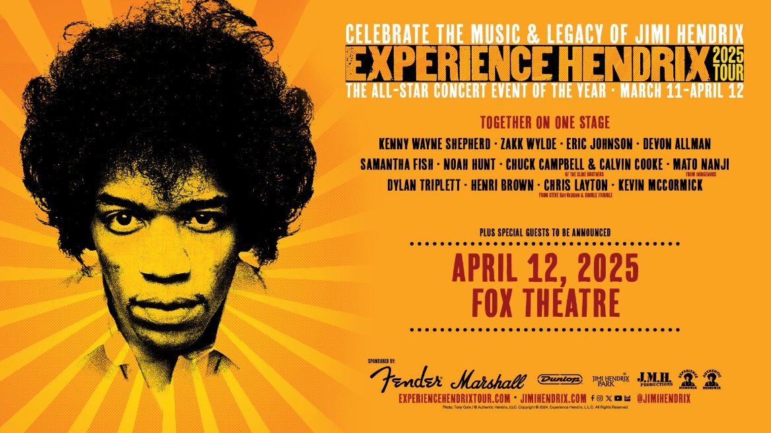
2025 Experience Hendrix Tour at The Fox Theatre On April 12
Lineup includes Kenny Wayne Shepherd, Zakk Wylde, Eric Johnson, Devon Allman, Samantha Fish, Noah Hunt, Chuck Campbell & Calvin Cooke of the Slide Brothers, Mato Nanji, Dylan Triplett, Artur Menezes, Henri Brown, Chris Layton and Kevin McCormick

ATLANTA – (Nov. 12, 2024) –The 2025 Experience Hendrix Tour will be at the Fox Theatre on April 12, 2025, with a lineup that includes Kenny Wayne Shepherd, Zakk Wylde, Eric Johnson, Devon Allman, Samantha Fish, Noah Hunt, Chuck Campbell & Calvin Cooke of the Slide Brothers, Mato Nanji, Dylan Triplett, Artur Menezes, Henri Brown, Chris Layton, Kevin McCormick and more. Tickets go on sale Friday, Nov. 15 at 10 a.m. and can be purchased on foxtheatre.org or by calling 855-285-8499.
The Experience Hendrix Tour, the only official multi-artist celebration of Jimi Hendrix’s musical genius that made a triumphant return this year after a half-decade hiatus, has just announced its 2025 edition. Starting at Taft Theatre in Cincinnati and winding its way through the Midwest (with a stop at Toronto’s famed Massey Hall), the tour continues down the East Coast and through the South, concluding in Atlanta at The Fox Theatre. The tour once again presents a diverse, star studded lineup for next year and features select dates from Experience Hendrix Tour mainstays such as Kenny Wayne Shepherd, Zakk Wylde (Pantera, Black Label Society, Ozzy Osbourne) and Eric Johnson, as well as Devon Allman (Allman Betts Family Revival), Samantha Fish and Christone ‘Kingfish’ Ingram. Marcus King is a first timer for 2025 and is sure to bring a fresh, new energy to Hendrix’s timeless repertoire.
“Jimi has long been a big influence in my musical journey,” said Mississippi-born blues guitar phenomenon Christone ‘Kingfish’ Ingram, who is both a Grammy Award winner and was named Contemporary Blues Male Artist of the Year at least year’s Blues Music Awards. “The opportunity to join the Experience Hendrix Tour in fall 2024 was fantastic, so I look forward to hitting the stage with the Hendrix crew this spring as we bring this exciting show to more North American cities.”
In addition to having released multiple solo albums since the age of 20, Grammy-nominated singer/guitarist Samantha Fish collaborated with Cassie Taylor and Dani Wilde for the “Girls with Guitars” album in 2011 and joined forces with Jesse Dayton last year for the album “Death Wish Blues.” She is the recipient of the Living Blues Award, Blues Music Award, Blues Blast Music Award and 22 Independent Blues Awards, and has also achieved the No. 1 slot on the Billboard Top Heatseekers and Top Blues Albums charts numerous times. Her live performances, in which she effortlessly blends blues, rock and soul, are a testament to her status as a true musical powerhouse. Fish stated, “2024 was my first year with the event. It’s really cool to see so many stellar musicians celebrating Jimi Hendrix’s legacy and catalog of music. It’s amazing that one musician can have such an impact on artists for generations, and it’s really awesome to hear how everyone interprets his music. I’m really looking forward to what’s coming next year.”
South Carolina native singer-songwriter/guitarist Marcus King got his start as a child playing with his father’s band. His unique brand of “soul-influenced psychedelic Southern Rock” caught the ear of the Black Keys’ Dan Auerbach, who produced and released King’s 2020 debut solo album “El Dorado.” His career immediately skyrocketed; he racked up streaming numbers in the tens of millions and a Grammy nomination. He has since released two more albums, including this year’s “Mood Swings,” which received rave reviews in Rolling Stone and No Depression. “The ferocity and aggression Hendrix played with was what I was immediately drawn to,” said King. “A soft-spoken man allowing his instrument to truly be his VOICE – channeling all his frustrations and pain through this vessel. I’m so honored to pay homage and respect to such a Giant and key contributor to my Musical biological makeup.”
Guitarist/vocalist/songwriter Devon Allman has been making music since the 1990s in various bands (Honeytribe, Royal Southern Brotherhood) and as a solo artist, before founding The Allman Betts Band in 2018 with Duane Betts. There is a familial connection, as their fathers Duane Allman and Dickey Betts were in The Allman Brothers Band, who played the 1970 Atlanta International Pop Festival with the Jimi Hendrix Experience. Devon Allman’s musical style ranges from Southern Rock to soul to blues, making him a perfect candidate for taking on the immense challenge of doing Hendrix’s music justice in a live setting. “Really looking forward to celebrating the eternal, cosmic music of Jimi Hendrix,” stated Devon Allman. “His singing voice has inspired me just as much as his ethereal, Martian, liquid-esque guitar. It’s gonna be a stone-cold groove…be with us!”
Kenny Wayne Shepherd’s soulful and pitch-perfect guitar playing has been a key component of the Experience Hendrix Tour for many years. The five-time Grammy nominee and recipient of two Billboard Music Awards commented, “I’m excited to be a part of the Experience Hendrix Tour again. This tour always offers fans a unique opportunity to see artists from multiple genres of music all honoring the great Jimi Hendrix. The diversity of the artists that take part every year only goes to show the vast reach of Jimi Hendrix’s influence.”
Among the other artists featured on the 2025 Experience Hendrix Tour are Texas blues sensation Ally Venable, Chuck Campbell and Calvin Cooke (Slide Brothers), vocalist Noah Hunt and bassist Kevin McCormick (both of Kenny Wayne Shepherd Band), Mato Nanji (Indigenous), blues guitar prodigy Mathias Lattin, Brazilian guitarist Artur Menezes, vocalists Dylan Triplett and Henri Brown and Rock and Roll Hall of Famer Chris Layton (Stevie Ray Vaughan and Double Trouble).
The 2025 Experience Hendrix Tour is sponsored by Marshall, Fender Musical Instruments and Dunlop. Marshall amps have long been associated with Jimi Hendrix and were his amplifiers of choice during his career. Fender is now celebrating the 70th anniversary of the Fender Stratocaster, the guitar most often associated with Jimi Hendrix. Dunlop makers of gear and accessories recently launched line of Authentic Hendrix ’68 Shrine Series of stomp boxes/effects pedals.
Visit www.experiencehendrixtour.com for artist lineups by date.
###
About the Fox Theatre
The Fox Theatre is one of Atlanta's premier venues for live entertainment, welcoming more than 200 performances a year in its 4,665-seat theatre. From concerts to ballets, comedy, and movies, the historic venue attracts more than 500,000 visitors annually. The theatre hosts over 100 annual private events like wedding receptions, trade shows, corporate meetings, and association functions in two fabulous ballrooms. The Fox’s premium Marquee Club, presented by Lexus, is a 10,000 sq. ft, three-story luxury bar accessible to all Club Level ticket holders or annual members of the Fox Theatre. As a 501(c)(3) nonprofit arts organization, the Fox Theatre is a fiercely protected landmark and nationally acclaimed theatre today. The Fox Theatre proudly acknowledges its partners' generous support: Coca-Cola, Georgia Natural Gas, Georgian Terrace Hotel & Livingston Restaurant, Humana, Lexus, Northside Hospital, and Regions Bank. Tickets for all events are available at FoxTheatre.org, or toll-free at 855-285-8499. Stay connected by following the Fox Theatre on social via @theFoxTheatre on Instagram, Twitter, and Facebook.
Notable accolades include 2023 Billboard Magazine #2 Highest Grossing Theatre Worldwide (5,000 seats or less); 2023 VenuesNow Magazine #2 Year-End Top Stops (2,001-5,000 seats); 2022 IEBA Theatre of the Year; 2021 Billboard Magazine #1 Highest Grossing Theatre Worldwide (5,000 seats or less); 2021 Pollstar Magazine #2 Theatre Worldwide in Ticket Sales and 2021 VenuesNow Magazine #2 Year-End Top Stops (2,001-5,000 seats). Additionally, in 2019, the Fox Theatre was honored with the VenuesNow #1 Top Stop of the Decade Award for Tickets Sold, further cementing its reputation as a premier entertainment venue.

